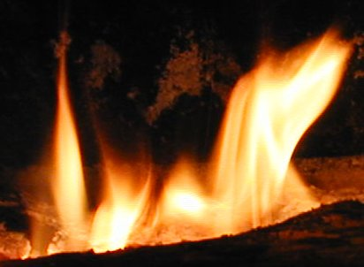

FANNING THE FLAMES

Inside this issue
Ice Rescue ………..……….1
Rosie 2
EGH ………………….3
Keep Warm .………….4
Rink Fire 5
Pancakes…………… …………6

Firefighter’s Newsletter

February, 2010
Volume 3, Issue 2
Love those pink engines!
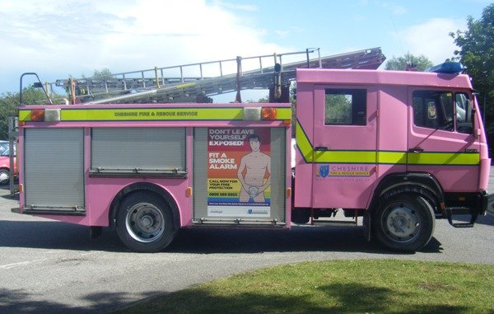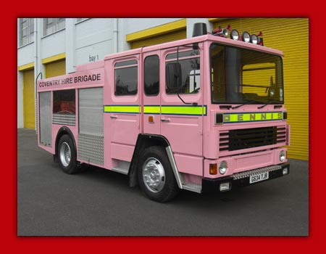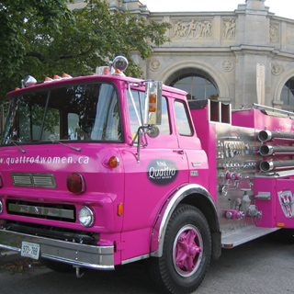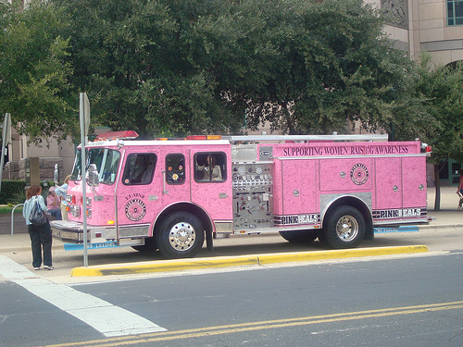

Basic Ice Rescue for Firefighters
By Steven Orusa
On a brisk December morning, a woman and her dog walk along a city bike trail next to an ice-covered pond. Her unleashed dog wanders out on the pond and suddenly a small cracking sound becomes a deep splash. The woman is horrified to see her dog scrambling as his hind quarters sink into the frigid water. The hole where the dog broke through the ice spreads quickly as he thrashes to get out. The woman panics and runs on the ice to save her dog. She lies down on the ice to grab her dog and the ice under her gives way. She slides head first into the water.
Two joggers hear the splashing; one runs to the parking lot to call for help. The other looks for a long branch to reach the woman in the water. The victim is screaming for help and bobbing under the surface amidst her dog's thrashing.
Ten minutes later, a rescue truck with four rescuers arrives at the head of the trail to find a locked access gate blocking their way. Three rescuers run down the trail with two ropes and a ladder, while the driver awaits city personnel to open the gate. The rescuers find the victim still on the surface and the civilian rescuer lying out on the ice extending a tree branch to the victim. The ice cracks under the civilian and she falls into the frigid water. A firefighter uses the first rope to tie himself to the ladder and slides out on the ice, carrying the other rope. He comes within 6 feet of the second victim and the ice suddenly gives way. The firefighter slides under the water, pulled down by the weight of the ladder.
Too often, this kind of incident results in tragedy, because many fire departments are untrained and ill-equipped to handle ice-related emergencies. Firefighters, police and other rescuers often become additional victims during rescue attempts. Understanding the conditions specific to an ice rescue, such as victim hypothermia and ice formation, can make the critical difference in a rescue attempt. With proper training, rescuers can save victims more often without risking the safety of their own personnel.
Chief officers have a covenant with their people to prepare them to be successful. The National Incident Management System identifies life safety as a top strategic priority. But with limited funding available for training, equipment and overtime, how can a department implement a safe and effective ice-rescue capability?
A successful ice rescue is based on a recognized and logical process inherent in any rescue operation. This process includes five basic steps:
- Evaluate scene conditions;
- Evaluate victims condition;
- Assess personnel and equipment;
- Develop operational plan; and
- Evaluate the rescue process throughout.
Proper scene evaluation is crucial and should begin immediately upon notification of the incident. Personnel should have a current knowledge of community geography, emergency resources and current weather conditions. The rescuer starts assessing information en route to the scene, relying on preplanning and dispatch information.
The victim's location is critical to determining how to access the victim and evaluating the victim's condition. If the victim is visible from shore, the rescuer can observe the stage of hypothermia and select appropriate equipment or resources to facilitate a rescue.
If the victim has slipped beneath the surface of the ice or water, the situation becomes more complex. The point where the victim was last seen must be determined and preserved. The operational plan immediately shifts to include public safety ice dive operations. It is prudent to initiate the response of a public safety dive team at the same time as the ice-rescue response. If one is not available locally, mutual aid agreements can provide this service. Time is critical, and the sooner the victim is found and medical treatment administered, the better the odds for a full recovery.
An evaluation of available personnel and equipment will enhance the chances for a successful rescue. Personnel evaluation goes beyond counting those who have responded to the scene. Knowing the availability and capabilities of additional mutual aid resources should be included in the evaluation process. Joint training exercises and standardized operating guidelines between mutual aid companies improve safety and effectiveness.
Before implementation of the operational plan, the rescuer must make an analysis of the risk-benefit factor, a subjective evaluation of the merits of the operation. Does the benefit of the operation justify the risk personnel must take to achieve it?
The risk-benefit analysis is not a mathematical formula that yields an absolute answer. It is a much more complex and subjective determination by the team leader on how much risk the team should or should not accept in order to accomplish the mission. The analysis depends on the knowledge, skill, ability and experience of the leader. The key to a successful operational plan is to keep it simple and have a back-up plan. Making a swift rescue while minimizing risk, equipment and personnel are the goals of an optimal operational plan.
Conditions of the rescue process do not remain static and the evaluation process is ongoing; any new developments may change, stop or allow an operation to begin. Preparing personnel to be successful by providing safe and effective training and equipment will lower the risk factors.
The cost of preparing a team starts with a preseason review of the team's level of capability. This review should include the number of personnel available and their current level of training, the types of equipment available and the response plan.
Most rescues can be accomplished with a few skilled rescuers working together efficiently. A certification program for rescuers can be accomplished in one eight-hour day. The most cost-efficient way to provide ice-rescue certification is to have an ice-rescue trainer on staff regionally. Several departments within a response area share the cost of educating the trainer, who is then a resource for training department members. Depending on the agency, the cost for certifying an ice rescue trainer is about $425.
Training should be provided by a certifying agency that offers the following:
- Public safety ice rescue training standards;
- Public safety ice rescue specific curriculum;
- NFPA 1006- and 1670-compliant program;
- Instructors with operational experience;
- Affordable instructor training; and
- Current references.
With these factors in mind, research successful departments and use them as a resource. Learn whom these departments trust to provide them with a safe and effective public safety ice-rescue training system.
Once the region or department has a trainer on staff, the cost for training materials to have response personnel certified is about $15 per rescuer. Once personnel are certified, pre-season continuing education and skill review will provide ice-rescue skills maintenance.
The equipment used for an ice rescue should be consistent with the preplanning that determines personnel and procedures. Some equipment may need to be available through other agencies. Surveying the response area prior to the ice season will aid in developing a list of equipment needed. When selecting equipment, evaluate it for safety and effectiveness, ease of use and durability. Although cost is a consideration, substandard equipment never should be used.
The trained rescuer has four major categories of operational plans from which to choose: self-rescue, reach, throw and go.
Self-rescue can be for both the rescuer and the victim. Rescuers need to know how to save themselves if they go in, or how to talk a victim out of the water. The use of ice awls and the proper technique to climb out of the ice are essential skills for all rescuers. The reach technique is simple and used when the victim is close to a rescuer. This form of rescue may be as simple as extending an outreached arm, but more commonly requires some type of extension device for the rescuer to reach the victim. In the throw technique, the object being extended to the victim is thrown rather than placed before the victim. This allows for a much greater distance between rescuer and victim and still maintains a high degree of safety. For these plans to work, the victims must be able to assist in their own rescue by grasping and holding the object extended to them.
The go operational plan should only be used when the reach and throw options will not work. Victims that reach the second or third stage of hypothermia may be unable to aid in their own rescue. In this case the rescuer must go to the victim and make direct physical contact to facilitate a rescue. Exercise extreme caution, as this plan places the rescuers at greatest risk. There are several go rescue techniques, and based on the conditions at the scene of an ice incident, the rescuer will have to choose which techniques and equipment to use.
The one-man rescue is the most common go rescue technique. The rescuer is dressed in an exposure-protection suit and fitted with a chest harness. If a suit other than an ice-rescue suit is used, a personal floatation device is worn over the suit. The rescuer's chest harness is attached to a tether line with a locking carabiner. Then a figure eight on a bight is tied in the line 18 inches from the rescuer and an ice-rescue carabiner (with the locking collar removed) is placed in the loop. This is used to secure the line around the victim. The other end of the line is secured to the shore or to the ice with an ice screw. This system is then duplicated for the back-up rescuer.
Determine the response plan before an ice-rescue emergency, and include a procedure for notifying agencies and specialists. Planning starts with a preseason review of a team's level of preparedness. The operational plan chosen must be re-evaluated continually. Conditions my change suddenly, and the planned technique may be inappropriate for the new developments. The victim may slip under the water in the midst of a reach, throw or go operation, and a public safety dive team may have to go after the victim. Weather conditions may deteriorate, causing complications in the rescue process. The rescuers may discover an additional victim who is submerged beneath the water as they attempt to rescue the original victim. The risk-benefit factor must be re-evaluated to accommodate new conditions. The rescue may be stopped should the conditions become unstable, causing too great a risk to the rescue team.
Conversely, an operational plan that could not be used may become an option as additional personnel and equipment become available. The incident commander must exercise flexibility with the operational plan and respond to new conditions with an alternative approach.
Educating the public on the dangers of being on the ice can help prevent tragedies. With an effective, planned approach to successful ice rescue operations, and public education, fire departments can gain positive public support and lower the risk to their personnel. Sharing the burden for training and equipment can produce a safe and cost-effective ice-rescue capability.

Basic Equipment for One Rescuer for a Go Rescue
Ice-rescue suit: Provides both warmth and flotation; has universal sizing; and hood, boots, gloves and chest harness are attached. Approximate cost is $500.
Ropes: Water-rescue ropes must be at least 3/8-inch diameter, 2,000-pound or greater tensile strength and flexible at low temperatures. Have multiple lengths of a minimum 200 feet. Approximate cost for 200-foot length and rope bag is $130.
Carabiners: Use assorted aluminum or steel, locking or non-locking with a minimum rating of 2,000 pounds. Approximate cost for one ice rescue carabiner and two aluminum carabiners is $60.
Personal self-help equipment: Ice awls and fins. Approximate cost is $120.
Approximate total cost to outfit one rescuer: $810.

Additional Basic Equipment
Reach devices: Pike poles and ladders.
Throw devices: Water rescue throw bags, life rings and floatation buoys.
All personnel near the water should wear a personal flotation device.
A 24-year fire service veteran, Steven Orusa is a captain in charge of the training division for the Waukegan (Ill.) Fire Department. He is the director of the International Association of Dive Rescue Specialists Response Team, chairman of the Illinois Office of the State Fire Marshal's water-rescue committee, and co-chair of the Illinois Mutual Aid Box Alarm System's water-operations committee. He is the regional team leader for the MABAS Division 4 & 5 Dive Rescue Team in Lake and McHenry counties, Ill. His most recent book Dive Rescue Specialist: Operational Training for Public Safety Divers was published in September 2007. Orusa has provided analysis on public safety diving for USA Today, FIRE CHIEF magazine, Dive Training magazine, and has appeared on MSNBC, FoxNews and CNN.

Report stresses use of SCBA after W. Va. mobile home LODDs (Line of Duty Deaths)
By Ken Robinson
FireRescue1 Staff
CRAIGSVILLE, W.Va. — Investigators are stressing the need for firefighters to use SCBA during all stages of fires after finding that two West Virginia firefighters were not wearing face pieces at the time of their deaths in a mobile home fire.
Investigators could not determine if volunteer Lt. Johnnie Hammons and firefighter Timothy Nicholas, both of the Craigsville Beaver Cottle Fire Department, were on air when they entered the mobile home on February 19 earlier this year, according to a NIOSH firefighter fatality report issued Monday.
Several attempts were made to locate the victims after they failed to respond to evacuation calls, and their bodies were eventually found several feet from the front door they had entered through.
The firefighters' bodies were discovered without properly donned protective equipment.
"Both victims' face pieces were found hanging at waist level with their regulators attached, possibly indicating that they were stored in this manner," the report said.
The victims were also discovered with their hoods rolled down on their necks, and investigators say Lt. Hammons' helmet was found melted on a couch next to firefighter Nicholas "as if it had been taken off and laid there."
The firefighters' face-mounted regulators were discovered hanging at waist level, connected to the SCBA face pieces, which were covered by soot on the outsides and insides.
Medical examinations revealed the firefighters died from smoke inhalation and thermal inhalation burns, with lethal doses of cyanide present in their systems.
The report also recommends fire departments ensure that all SCBA are equipped with an integrated personal alert safety system (PASS) device, after investigators found the victims were using SCBA that did not have integrated or standalone PASS devices.
Investigators also recommend that all firefighters should be equipped with a means to communicate with fireground personnel before entering a structure fire, as the victims were discovered without their department-issued radios which were later found at the fire station.
"Radio communications on the fireground is imperative for the IC to command and control the incident and for fire fighters working within a structure fire," the report said. "Firefighters within a structure are unable to see all areas affected by fire and whether the structure is maintaining its stability."
In conclusion, NIOSH recommends fire departments minimize the risk of similar occurrences by:
• Ensuring firefighters use their self-contained breathing apparatus (SCBA) during all stages of a fire due to the potential exposure and health affects of fire-produced toxins
• Ensuring that all SCBAs are equipped with an integrated personal alert safety system (PASS) device
• Ensuring that all firefighters are equipped with a means to communicate with fireground personnel before entering a structure fire
• Ensuring that the incident commander (IC) does not become involved with fire fighting activities
• Ensuring that the incident commander (IC) maintains close accountability for all personnel operating on the fireground and that procedures and training for the use of a personnel accountability report (PAR) are in place
• Ensuring that a properly trained incident safety officer (ISO) is appointed at all structure fires
• Ensuring that a rapid intervention team (RIT) is established and available to immediately respond to emergency rescue incidents
• Ensuring that hoseline operations are properly coordinated so as not to impede search-and-rescue operations
• Developing, implementing, and enforcing written standard operating procedures (SOPs) for fireground operations
• Ensuring that all firefighters properly wear their department-issued turnout gear and personal protective equipment (PPE) during fire suppression activities
• Developing and maintaining a comprehensive respiratory protection program
• Ensuring that firefighters are aware of the dangers involved in fighting mobile home fires
• Ensuring that policies and procedures for proper inspection, use, and maintenance of self-contained breathing apparatus (SCBA) are implemented to ensure they function properly when needed
Mark-A-Hydrant
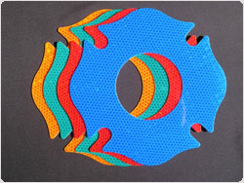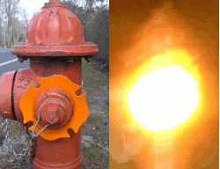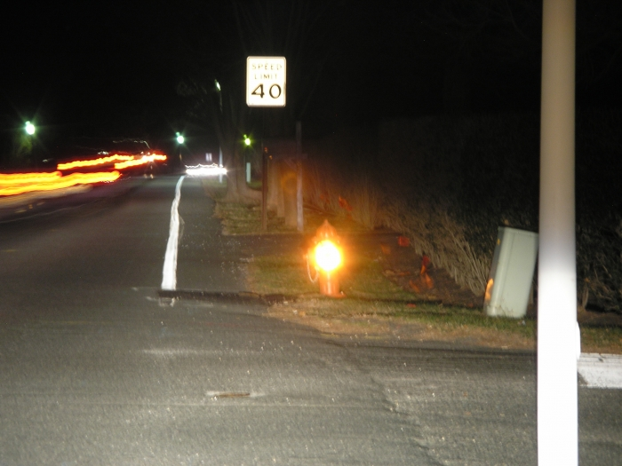
Dogs aren’t the only ones who can mark a hydrant. If there was just a way make it so that the hydrant was easy to see at night and you could tell the line pressure as soon as you pull up to it. There is it is called “Mark-A-Hydrant”.
Mark-A-Hydrant is not the first to recognize that finding Hydrants at night is a matter of life and death, but our solution is the simplest and most visible.
These cost-effective markers are easily recognizable, due to their patented shape, and make flow rate identification, immediate -- as they are offered in the NFPA standard flow rate colors.
It's been said that the "simplest solution is very often the best solution." That notion wasn't lost on the folks at Mark-A-Hydrant. That's why our product is not only extraordinarily effective, but extremely simple.
The installation of this product is really self-explanatory -- as you can see from the pictures at the right -- but here are the steps:
- Have an authorized individual remove the cap(s) from the hydrant (either the "hose connection," or "pumper" caps).
- Place the appropriate color and size reflector over the exposed threads.
- Replace the cap and re-tighten. 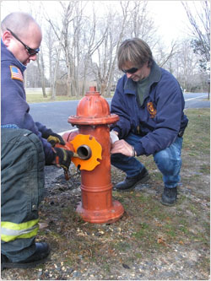
It's really that simple -- and takes no more than a minute or two per hydrant.
Oh...there is one more step...marvel at how easy it is to spot hydrants at night!!!
Check this product out at: http://www.mark-a-hydrant.com
Tones!
By: Jay Diemert
January 8th did not start like any other day in the Canadian prairie town of Kindersley Saskatchewan. They were holding the provincial women’s curling championships at their event center. At about 1000h the fire alarms sounded in the building. One of the attached skating rinks was on fire.
The fire started at the north end of the old rink and did not take long to consume the building. The rink was built in the early 1950’s. It was a barn shaped structure with large beam truss style roof. The fire fed on a fuel of decades old dried wood, layers of paint and asphalt shingles.
The events center was evacuated into the cold January morning after someone confirmed that there was smoke in the entryway. There was some doubt due to previous false alarms the day before. Many of the curlers and officials were forced off the ice into the frosty parking lot with only what they were wearing. Much of their winter clothing and property was in lockers in the old skating rink.
One positive was that there was nothing going on in either the old rink or the new rink that day. The day before both rinks were being used for minor hockey and filled with kids. Sometimes fire can be merciful I guess.
The fire was burning freely in the north end of the building which contained the mechanical room and the ice cleaning equipment. The roof was just starting to burn through above this section when the Kindersley Volunteer Fire Department arrived on scene. A mutual aid call was sent and three other district fire departments were dispatched to Kindersley.
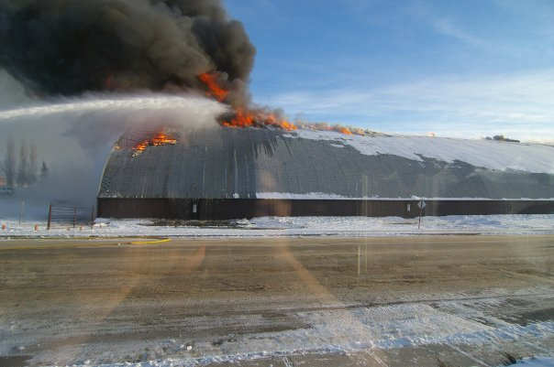
In talking with Fire Chief Ron Hope of the Kindersley Fire Department he related to me that this was by far the biggest fire challenge that his crew has ever faced. The Kindersley Fire Department is well run. They may be volunteers, but they are well trained and all certified firefighters.
The KFD set up for an offensive attack. They pressed in through the south doors through the lobby and were entering the rink when the north end collapsed. This sudden collapse pushed the air down the building with a wall of fire ahead of it. The fire shot over the interior team and blew out the doors and windows on its way to the parking lot on the south end of the building. The scene quickly changed to a defensive attack as the crew backed out.
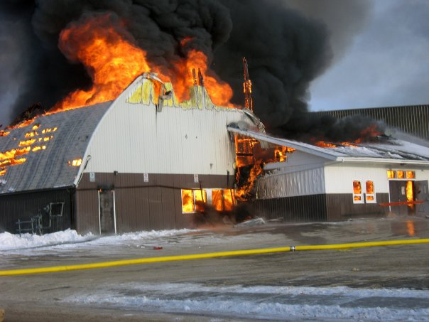
Ron then told me that he and a deputy chief knew that the fire doors that connected the old rink and the rest of the event center had to be check or this would become a whole new fire. They were able to check the south fire doors, but they could not go any further due to the advancing of the fire. The good news is that this time the fire doors were shut as they are intended to be and they did their job.
If there had not been a fire wall with all the fire doors properly closed the fire might have consumed both skating rinks and the curling rink. The sixty plus volunteer firefighters did their very best to deny the fire it’s day, but there really was nothing they could do to save the “old barn”. There was a lot of history lost that Friday morning. The lobby of the old rink was a museum of memories, memories of young men who went on to play in the NHL, six in total. There were also the memorials to those players who died way too young. These pictures and jerseys are now gone. 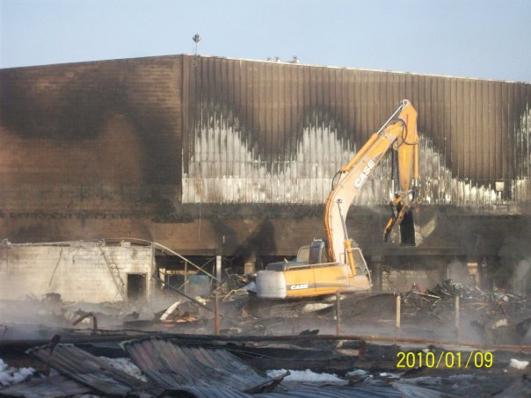
There were no injuries and no loss of life in this fire that will forever change the face of this small town. In years to come no one will remember who won the curling title, just the fire they all escaped. 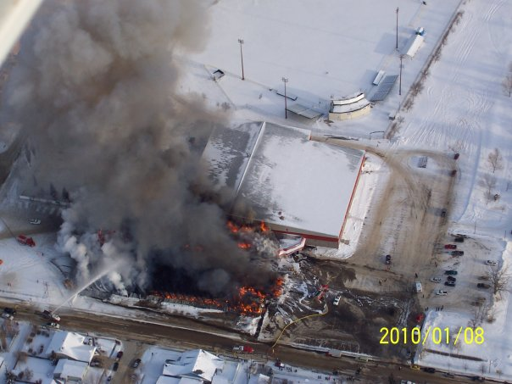
Fanning the Flames would like to salute our brothers who fought this fire. I personally am a bit jealous and would have loved to be there to fight for my hometown. Good work KFD you are truly among the best of us.
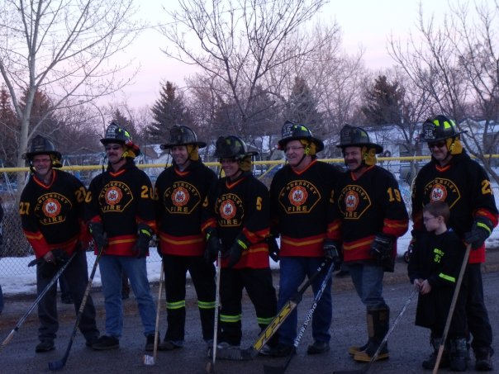


Buch Air

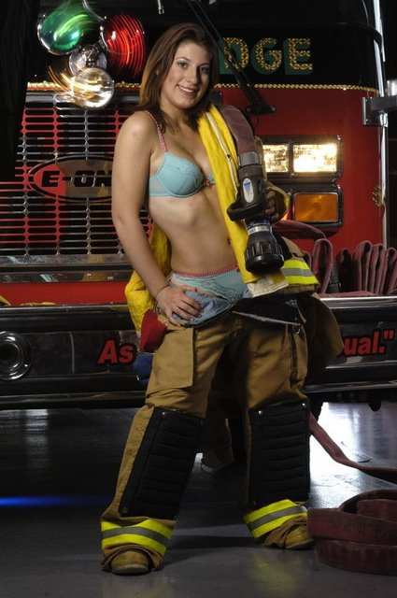

Blazing Hot Fire Wife Rosie!




Page Two Brought To You By:


POTM
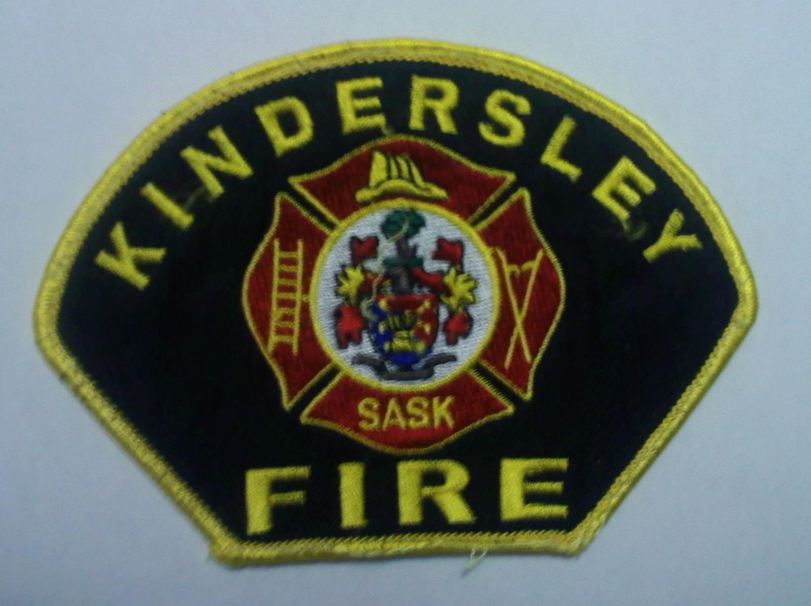
Kindersley Fire Department

Everyone Goes Home®
Second 8 of the 16 Firefighter Life Safety Initiatives
- Thoroughly investigate all firefighter fatalities, injuries, and near misses.
- Grant programs should support the implementation of safe practices and/or mandate safe practices as an eligibility requirement.
- National standards for emergency response policies and procedures should be developed and championed.
- National protocols for response to violent incidents should be developed and championed.
- Firefighters and their families must have access to counseling and psychological support.
- Public education must receive more resources and be championed as a critical fire and life safety program.
- Advocacy must be strengthened for the enforcement of codes and the installation of home fire sprinklers.
- Safety must be a primary consideration in the design of apparatus and equipment.

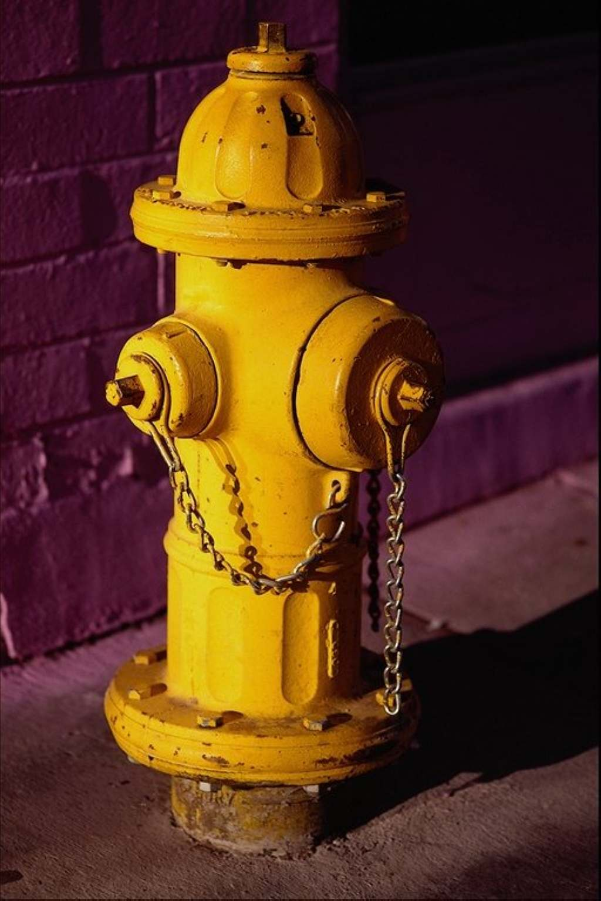
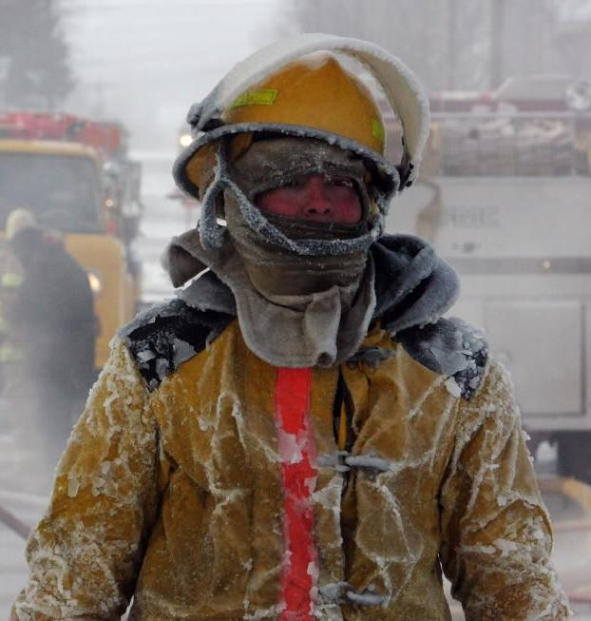
Keep Warm

Look Outs
This is your newsletter let us know what you want to see in it or just drop a line to let us know what you think. Send your emails to Jay Diemert at ftf@firefighting.net.
You can also check us out at our website www.fanningtheflames.synthasite.com. We are posting your tattoo, motorcycle and patch pictures at the site.





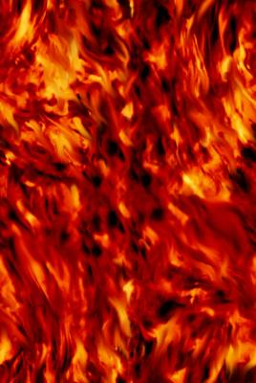

Buttermilk Pancakes
- 4 eggs or as many as 6 for high protein
- ¼ cup white sugar
- 2 tablespoons veg. oil
- 1 cup white flour
- 1 cup whole wheat flour or another cup of white flour
- 1 tsp of salt
- 1 tsp baking powder
- 1 tsp baking soda
- 2 cups buttermilk
Heat the griddle to 275 – 300 degrees. Low temp makes golden brown if darkening too fast lower temp. Combine eggs, sugar and oil till creamed. In separate bowl combine the flours, salt, baking powder and baking soda. Add the dries to the creamed along with the buttermilk. Fold with wooden spoon until combined. For thinner batter add more buttermilk. Ladle onto the griddle. When bubbles form on top flip and cook through. Remember it is golden brown you are looking for. Serve with maple syrup or even better Apple or Berry.
No Syrup in the Cupboard!
- 2 tablespoons butter
- ½ cup brown sugar
- ¼ cup water
Melt the butter in a large frying pan over medium heat Introduce the brown sugar, and meld the two together for about 3 minutes. Add the water to the meld slowly, as it will start to sizzle and bubble.
Variations: ½ teaspoon cinnamon and 3 large apples, cook in syrup for 8 minutes, if thin add 1 tablespoon water and cornstarch mixed together or just add some jam.
Recipe from “Fire Hall Cooking with Jeff the Chef” by Jeff Derraugh

